

MyChart Direct Scheduling Guide for Patients
This tip sheet outlines the CTC’s Direct Scheduling workflow through Epic’s MyChart application.
Patients will follow the steps below to schedule their own appointments directly from MyChart.

MyChart Online/ Mobile View:

- Select the Visits tab

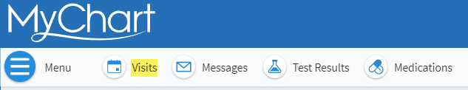

- Choose ‘Schedule and appointment’

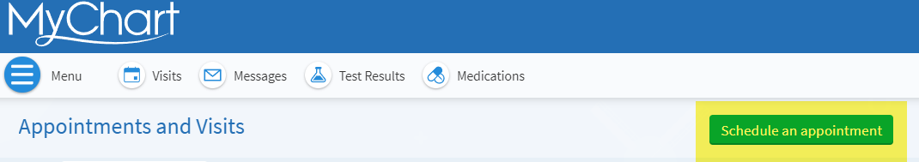

- Select the appropriate provider, based on your need, and who you have a history with. The, choose either an Office Visit (New Problem Visit), or a Follow Up (Problem Follow-Up Visit)

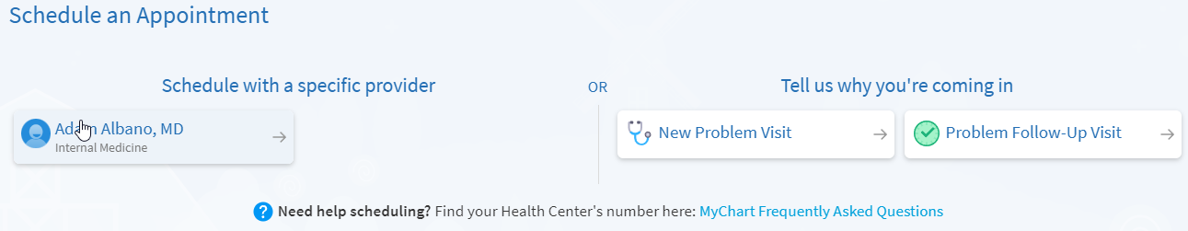

- Choose the date and time based on the providers availability, or choose ‘Start Over’ if that is needed.
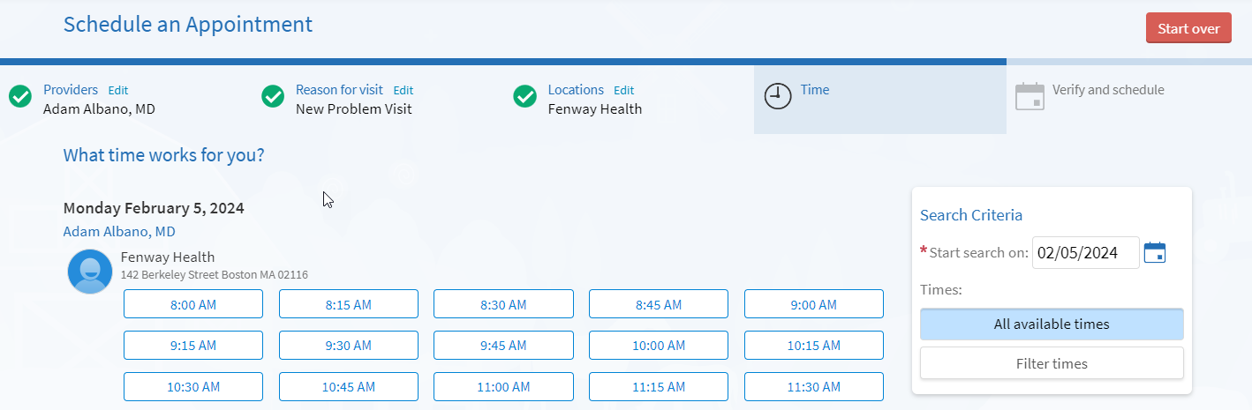

- You will need to enter a brief description of why you booked this appointment, and be sure to review the Visit Instructions prior to arriving. Click ‘Schedule it’ if everything looks correct
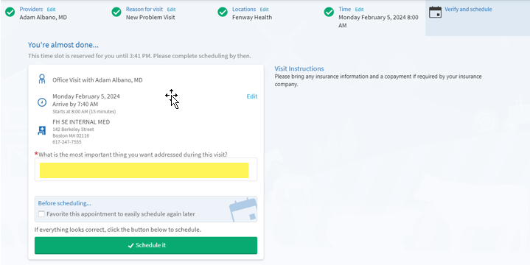

- Finally, confirm the appointment information, and you are all set!
